Encoder 8:3
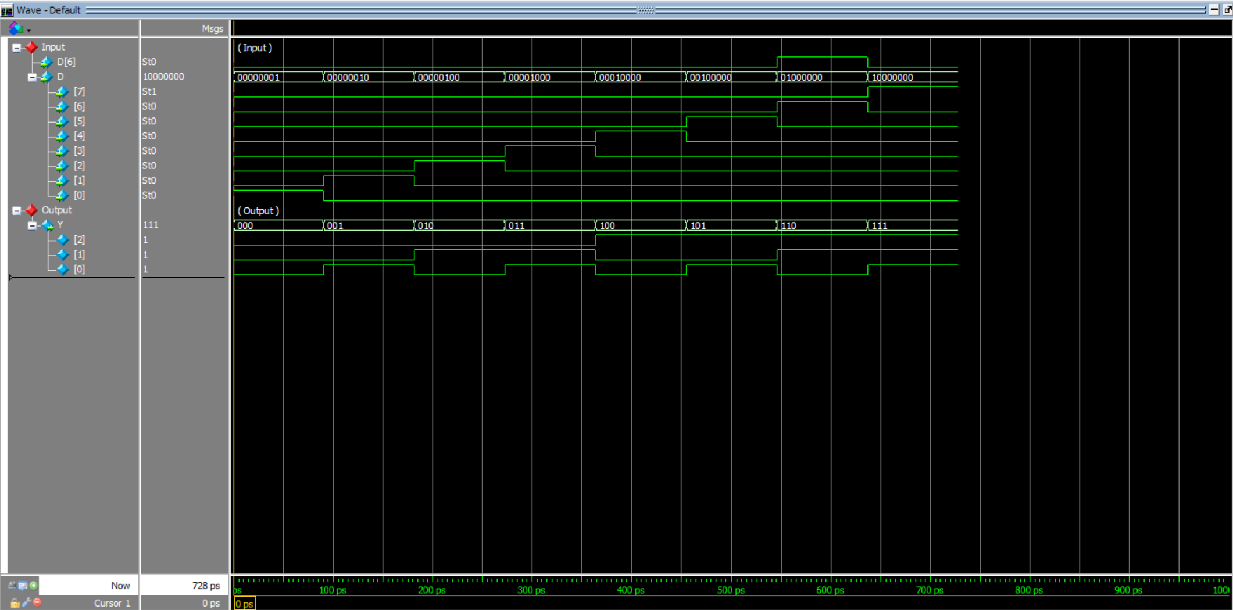
Decoder 1:16
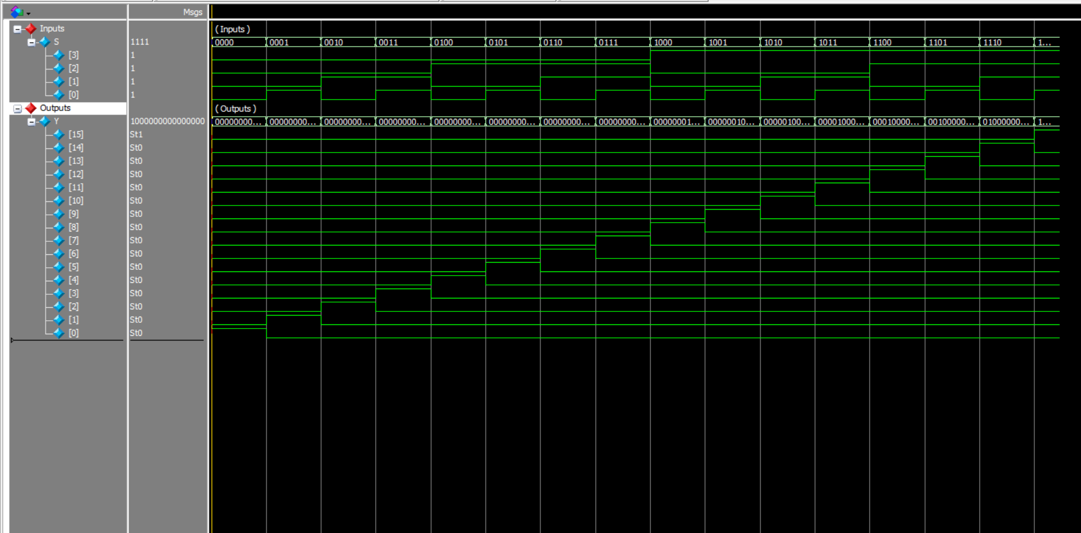
Title : Encoder 8:3
Reg.No : 23BEC1392
Date : 1 Sep 2024
Name: Bhargav Kulkarni

Title : 1:16 Demultiplexer
Reg.No : 23BEC1392
Date : Sep 1 2024
Name: Bhargav Kulkarni

